Geometry: Unit 6, Lesson 2
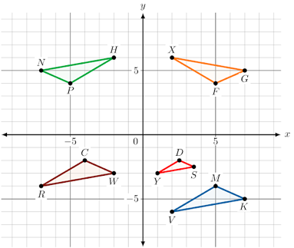
- The diagram shows four different single transformations of $∆VMK$. What triangle is created by rotating $∆VMK$?

$∆HPN$ is created by rotating $∆VMK$

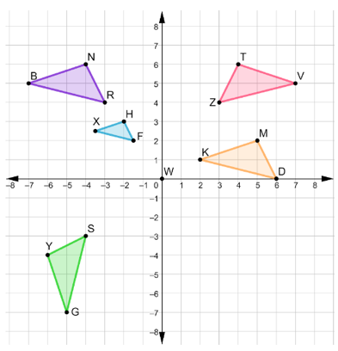

- The diagram shows four different single transformations of $∆NRB$. What transformation was applied to $∆NRB$ to create the triangle $∆YSG$.

Rotation
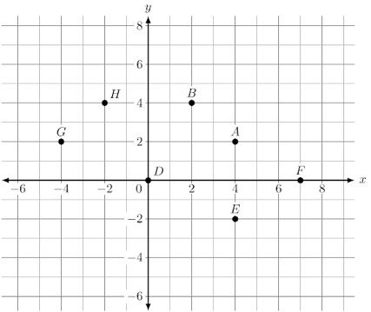
- An image of points on the coordinate plane is shown. What point represents the result if point $A$ is reflected over the line $y=x$?

Point $B$

